STATE OF TEXAS )(

LEGAL NOTICE

COUNTY OF BORDEN )(

**Sale of Surplus Equipment and Materials**

Borden County will except bids/offers for the following surplus items. Material and equipment lists will be updated each Wednesday throughout August, 2025. Material offers will be accepted in an ongoing basis. Equipment bids will be opened on August 26, 2025 at 9:00 a.m.

Equipment and materials may be inspected by contacting Cathy Palmer at 806-756-4391.

**Materials/Supplies Listing**

Offers will be evaluated and list updated each Wednesday. Offers will be accepted in an ongoing basis throughout the month of August.

1 Metal Desk

1 Metal Table with wood top

1 Commercial Reach-in Freezer (is not currently working)

2 Business Desk Chairs

Scrap Metal

10 fire extinguishers (working)

**Equipment Listing**

Bids will be taken on the following Equipment Items. Bids will be reviewed on August 26, 2025.

Broom Attachment for Skid Steer (Precinct 3)

Water Truck (2001) (Precinct 3)

Mach Truck (1986) (Precinct 3)

Trailer (1999) (Precinct 3)

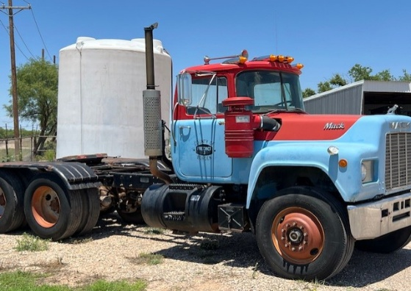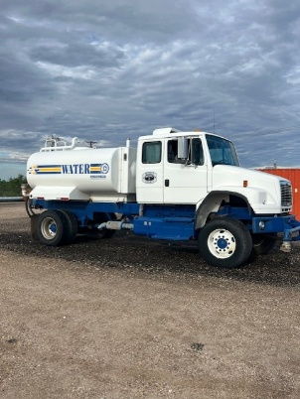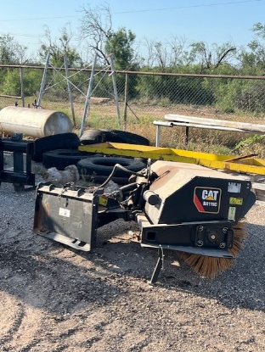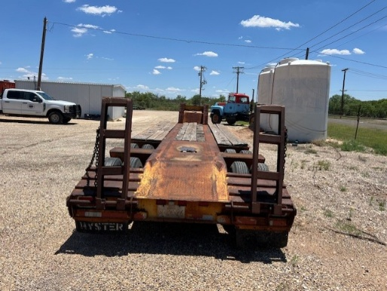

Mail bids for equipment to

Borden County Deliver bids to: Borden County

PO Box 156 117 E. Wasson

Gail, TX 79738 Gail, TX 79738

All bids for surplus equipment should be marked “BID” on the outside of the envelope.

Borden County reserves the right to reject any or all bids.

BY ORDER OF THE BORDEN COUNTY COMMISSIONERS COURT.

______________________________

Cathy Palmer

County Judge

Borden County